**Physics Lab Assignment**

**Assigned by Sir farhan**

**Done by**

**Muhammad Younis**

**Step Wise Circuit creation on Multisim**

**Step 1 : select new design**

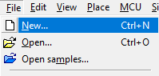

**Step 2 : select Blank design**

**Step 3 : Place Component**

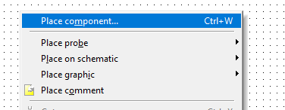

**Step 4 : Select sources from group**

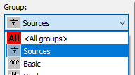

**Step 5 : Select DC_POWER Source**

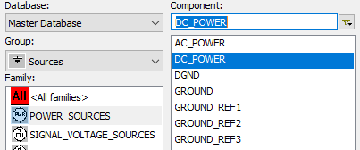

**Step 6 : Place DC_POWER component on the board**

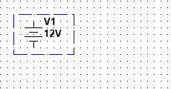

**Step 7 : Now Pick the GROUND Component from same group**

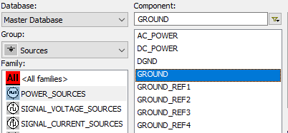

**Step 8 : Place GROUND component on the board**

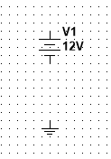

**Step 9 : Now Select the diode group for DIODE Component**

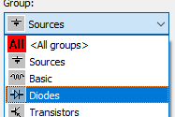

**Step 10 : Pick the DIODE Component from Diodes group**

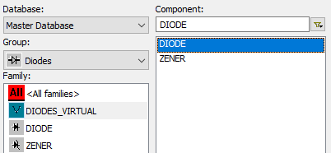

**Step 11 : Place DIODE component on the board**

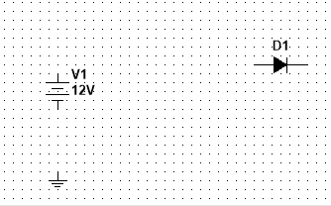

**Step 12 :Now select all group and search for the RESISTOR component**

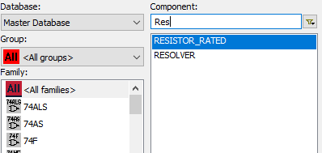

**Step 13 : Place RESISTOR component on the board**

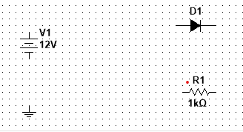

**Step 14 : Connect all the wires Accordingly**

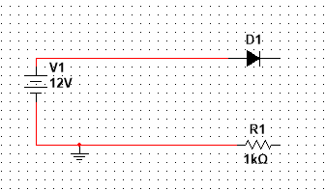

**Step 15 : Pick Multimeter From the Pallete in the right side**

**Multimeter**

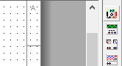

**Step 16 : Set 1st Multimeter to voltage, And 2nd Multimeter to Ampere**

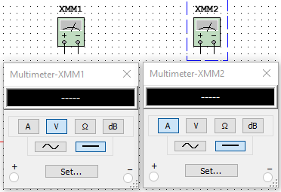

**Step 17 : Connect the Multimeter wires Accordingly ( Voltage meter in parallel and Ampere meter in series )**

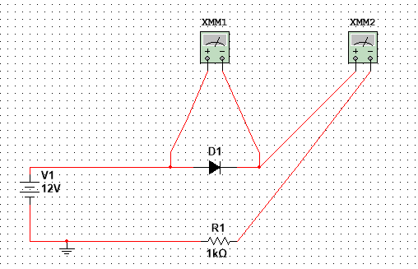

**Step 18 : Finally Press F5 for running circuit and then check Voltage meter and Ampere meter**

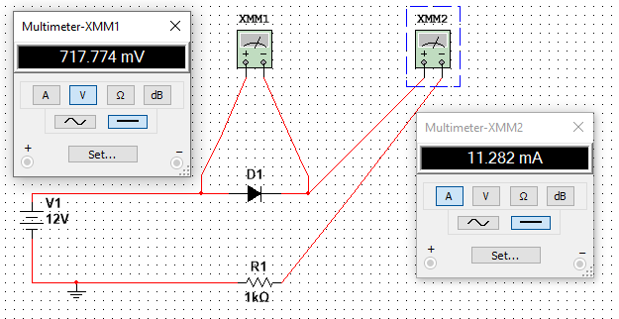

**The Sheet Mentioned Below Shows Voltage and Ampere Values on different source of voltage given**

|  |  |  |  |
| --- | --- | --- | --- |
| Power Source Voltage | Resister | Voltage At Diode | Ampere |
| 1V | 5K OHM | 590.387 mV | 81.923 uA |
| 2V | 5K OHM | 621.77 mV | 275.646 uA |
| 3V | 5K OHM | 635.728 mV | 472.854 uA |
| 4V | 5K OHM | 644.782 mV | 671.044 uA |
| 5V | 5K OHM | 651.489 mV | 869.702 uA |
| 6V | 5K OHM | 656.816 mV | 1.069 mA |
| 7V | 5K OHM | 661.236 mV | 1.268 mA |
| 8V | 5K OHM | 665.011 mV | 1.467 mA |
| 9V | 5K OHM | 668.306 mV | 1.666 mA |
| 10V | 5K OHM | 671.23 mV | 1.866 mA |
| 11V | 5K OHM | 673.857 mV | 2.064 mA |
| 12V | 5K OHM | 676.242 mV | 2.265 mA |

1. **What is P-N junction diode :**

A P-N junction diode is a semiconductor device made by joining p-type and n-type semiconductors together, which creates a depletion region and a barrier potential across the junction. The diode conducts electric current in only one direction, allowing the flow of electrons from the n-type to the p-type region.

**Application of diode**

Diodes have a variety of applications, including rectification, voltage regulation, signal mixing, signal modulation, and switching. They are used in electronic circuits, power supplies, radios, televisions, computers, and many other electronic devices.

**V-I characteristics of the Diode**

The voltage-current (V-I) characteristic of a diode is a graph that shows how the diode's current varies with the applied voltage. The V-I characteristic of a diode is nonlinear, and it exhibits a forward voltage drop and a reverse breakdown voltage.

**Types of Diode**

There are several types of diodes, including rectifier diodes, zener diodes, LED diodes, Schottky diodes, and varactor diodes. Rectifier diodes are used to convert AC to DC, zener diodes are used as voltage regulators, LED diodes are used as light sources, Schottky diodes are used in high-speed circuits, and varactor diodes are used in tuning circuits.

1. **Operation of P-N Junction Diode**

**What is Potential barrier ?**

When a P-N junction diode is formed, a potential barrier is created at the junction due to the diffusion of charge carriers. This potential barrier prevents further diffusion of majority carriers across the junction and creates a depletion region around the junction.

**What is knee voltage ?**

The knee voltage is the voltage at which the current through a diode increases rapidly with only a small increase in voltage. It is the point where the diode starts to conduct heavily in the forward direction.

**What is reverse leakage ?**

Reverse leakage is the current that flows through a diode in the reverse direction when a reverse bias voltage is applied. This current is due to minority carrier diffusion across the depletion region and is relatively small in a well-designed diode.

**What is breakdown voltage ?**

Breakdown voltage is the voltage at which the diode breaks down and starts to conduct heavily in the reverse direction. There are two types of breakdown voltage: Zener breakdown voltage, which occurs in a heavily doped diode, and avalanche breakdown voltage, which occurs in a lightly doped diode under high reverse-bias voltage.

1. **Biasing Conditions for the P-N Junction Diode**

**Zero Bias**

Zero bias is the condition when there is no external voltage applied to the P-N junction diode. In this condition, the diode operates based on the intrinsic properties of the semiconductor material and generates a potential barrier at the junction due to diffusion of charge carriers.

**Forward Bias**

Forward bias is the condition when the positive terminal of an external voltage source is connected to the P-type region, and the negative terminal is connected to the N-type region of the diode. In this condition, the applied voltage reduces the potential barrier, allowing current to flow through the diode in the forward direction.

**Reverse Bias**

Reverse bias is the condition when the negative terminal of an external voltage source is connected to the P-type region, and the positive terminal is connected to the N-type region of the diode. In this condition, the applied voltage increases the potential barrier, preventing current flow in the reverse direction. However, a small reverse current, known as reverse leakage current, flows through the diode. If the reverse bias voltage exceeds the breakdown voltage, the diode starts to conduct heavily in the reverse direction.

1. **Simulation of P-N Junction Diode Circuit**

**Forward Bias testing**

To simulate a P-N junction diode circuit in forward bias testing, one can use a circuit simulator software like LTSpice, Proteus, or Multisim. The diode can be represented by its model, which includes its forward voltage drop, reverse leakage current, and capacitance. Connect the diode in series with a resistor and apply a voltage source with a gradually increasing voltage. The current through the diode can be measured and plotted against the voltage. The current should increase rapidly after the knee voltage is reached.

**Reverse Bias testing**

To simulate a P-N junction diode circuit in reverse bias testing, the diode can be connected in series with a resistor, and a voltage source with gradually increasing voltage can be applied in reverse polarity. The current through the diode can be measured and plotted against the voltage. The current should be very low and almost constant until the breakdown voltage is reached, after which the current should increase rapidly.

**Conclusion**

In conclusion, simulating P-N junction diode circuits under forward and reverse bias conditions can help in understanding the electrical characteristics of the diode and its performance in specific applications. These simulations can aid in selecting appropriate diodes for a particular application and can help in the design and optimization of electronic circuits. The simulation results can also be compared with experimental results to validate the accuracy of the simulation.